Active Measurements of

Routes, Losses, and Delays Report



CIS 427 - Project 2

By:  
Veeram Hirekhan

Srinivas Simhan

***Abstract***

This report represents the usefulness of the “traceroute” and “ping” network diagnostic tools. We learned how to implement commands such as “tracert [insert website] > [name of .txt file]” and “ping -n 120 [insert website] > [name of .txt file]. Then we took the information gathered from each command and stored it on a .txt file in the C:/ drive as followed “C:/user/[name of user]/”. The tool “traceroute” tracks the route packets and take from sender to receiver and ping simple returns the RTT of packets sent and ACKs received. The “traceroute” and “ping” are taken for five consecutive days, twice a day, at different times, in the same location. One is during the morning and the other in the evening. Over the course of recording information, patterns of similarities and differences will be recorded and graphed to show how different factors affect how packets travel and for how long.

***Introduction***

This report will represent how network diagnostic tools, “tracert” and “ping”, are used through the command prompts. As control, all commands were sent from the Troy Public Library. The command “tracert” tracks the data flow from source to destination. By conducting it in the same place, this ensured that any variance in the route would be from instability and not because of location. The command “ping” simply returns RTT and though a distance of a few miles may not affect the time much, it may affect which route the packets take, which will affect time more greatly.

This project had two main objectives. One being identifying and using commands in your command prompt correctly so the load of information given can be analyzed and be useful to the user. This was done by using the “> [name of .txt file]” which stored all data in a txt file so multiple pings and tracerts could be conducted and saved over the course of five days to be analyzed. The second being analyzing those txt files and finding patterns, similarities, and differences that gives us insight to how the network is affected by outside factors. Our hypothesis was that the ping will be higher in the afternoon because of how many people attend the library compared to the mornings where not many people are there.

***Methodology***

The procedure we did to complete this project was simple. Utilizing commands such as “tracert [insert website] > [name of .txt file]” and “ping -n 120 [insert website] > [name of .txt file]” (fig. 1) put collected data in C:/user/[name of user] (fig. 2). From there, the txt files are copied to our Google Drive folder and separated the files by using folders (fig. 3). We chose the Library as our source point so that collecting data would be consistent and reliable. On each day, data was consistently collected from between 8am-12pm and 6pm-12am. The commands were entered on multiple command prompts at once to expedite the process.

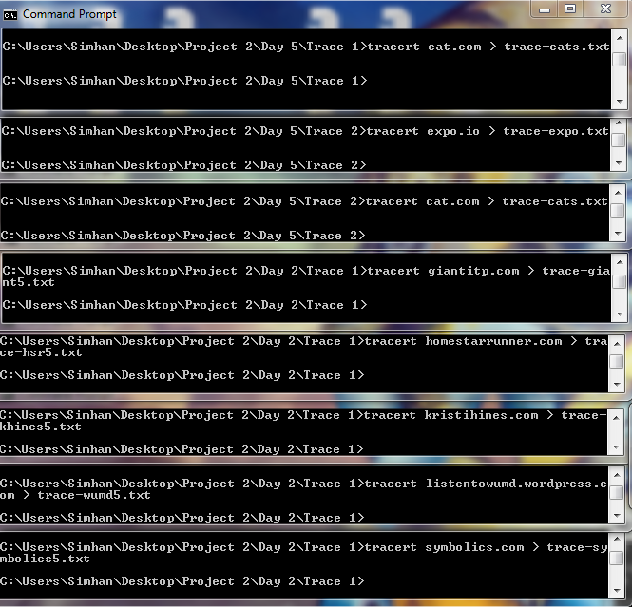

Fig. 1: tracert and ping for each website typed in at once. Each were directed into their respective folder that was made based on day and time. Here’s a few examples of what we typed into the command prompt to gather data.

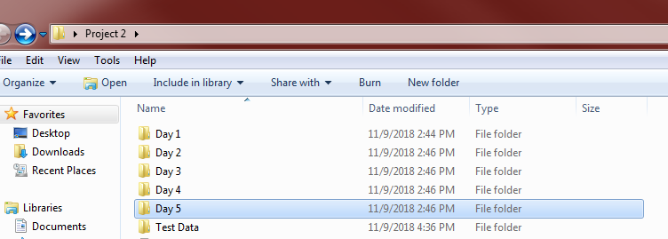

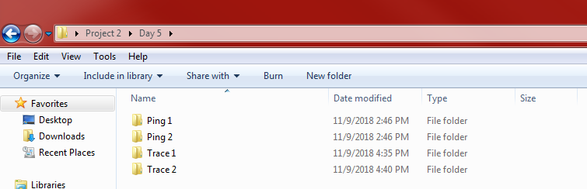

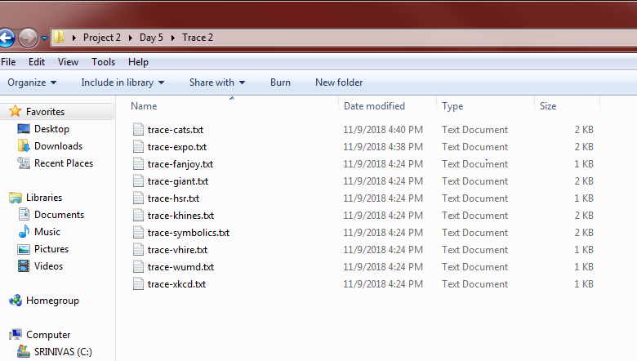

Fig. 2: tracert and ping information stored on .txt files on the C:/ drive into their respective folders.

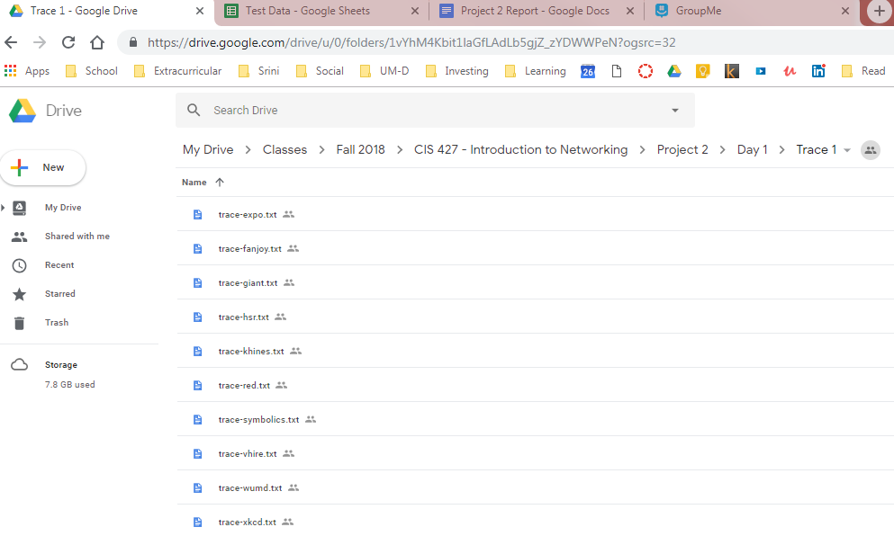

Fig. 3: All .txt files are copied to their appropriate folders and uploaded to Google Drive.

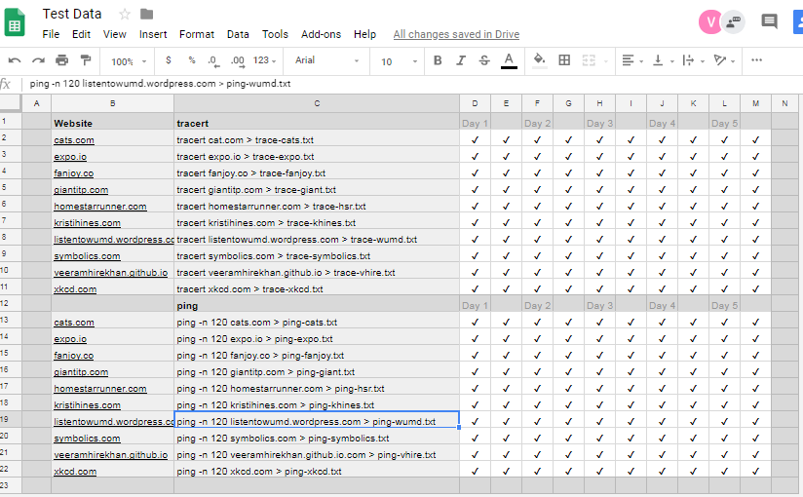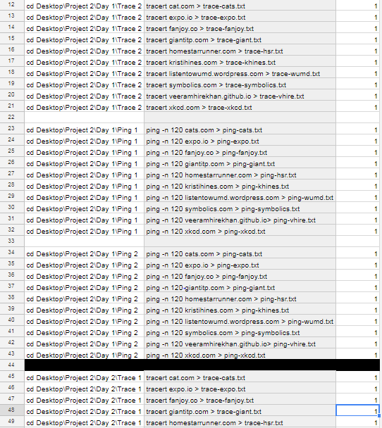

Fig. 4: All progress was tracked on google docs as well.

***Results***  
This projects results are defined in this section. Essential data relevant to the conclusion is given here.

**Tracert**

All websites that were traced were very stable. Notable changes in the stable connections were possibly due to traffic given the time they were recorded at. Though, [www.xkcd.com](http://www.xkcd.com) only noted a noticeable change in the trace on Monday and Wednesday during recordings, which I can be directed back to the activity of the site on that day was higher. All of the results vary slight in variance in most traced websites at the Troy Library’s network.

**Ping**

The data began being recorded on Saturday and until Wednesday. In each graph, 1-2: Saturday, 3-4: Sunday, 5-6: Monday, 7-8: Tuesday, and 9-10 Wednesday. The first being in the morning/afternoon and second in the evening/night. To decipher the data given, we must first find and separate the similarities and differences given in each group of pings.

**Similarities:**

In all of the groups of pings given to each website, a few notable similarities that stood out.

* Ping groups tend to be higher during the weekday rather than the weekend.
* All websites take longer to ping in the evening/night than morning/afternoon.
* Packet loss more often occurs during the weekday as well.
* All groups of ping are much more tightly bounded to the minimum ping than to the maximum ping.

**Differences:**

* Maximum ping was higher than the average ping rate.
* Packet loss percentage shown to be somewhat consistent as well, which can be attributed to the fact that the Troy Library had an event on that day of recording.

Below is all ping data collected and represented by graphs.

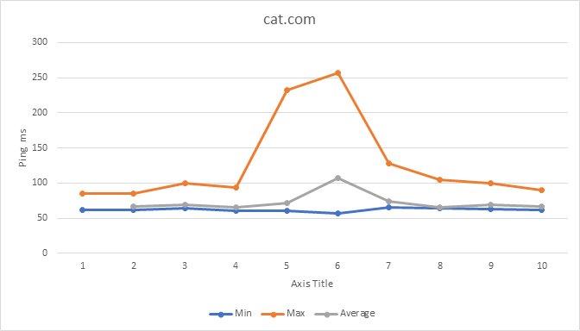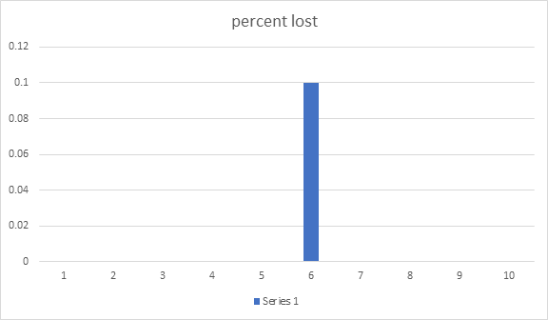

Fig. 5: cat.com ping and packet loss data.

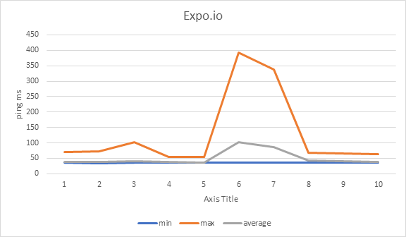

Fig. 6: expo.io ping and packet loss data.

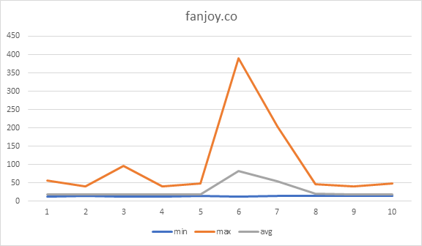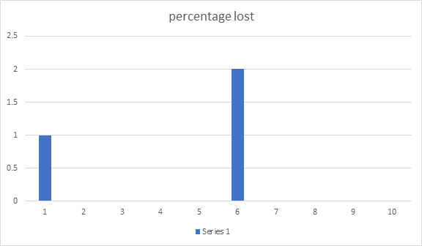

Fig. 7: fanjoy.co ping and packet loss data.

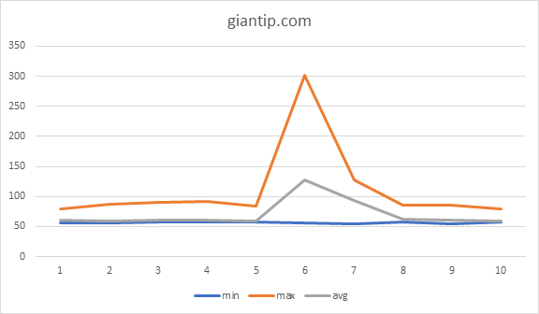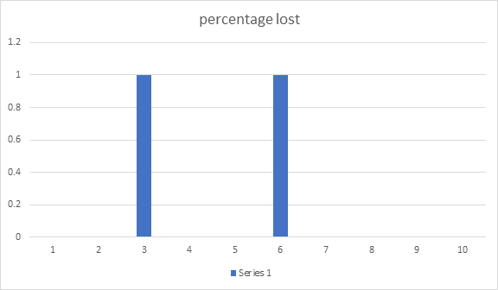

Fig. 8: giantip.com ping and packet loss data.

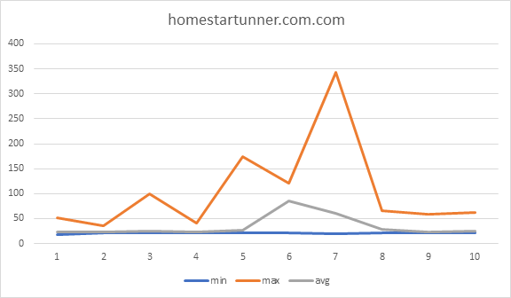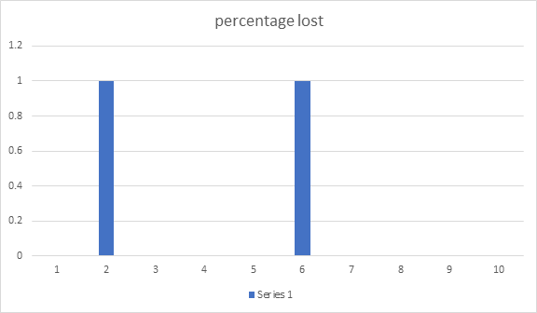

Fig. 9: homestarrunner.com ping and packet loss data.

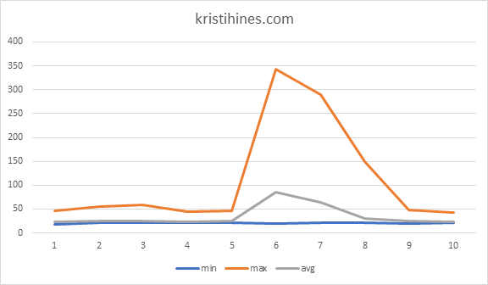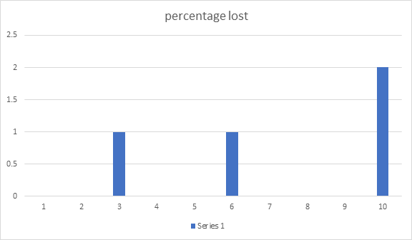

Fig. 10:kristihines.com ping and packet loss data.

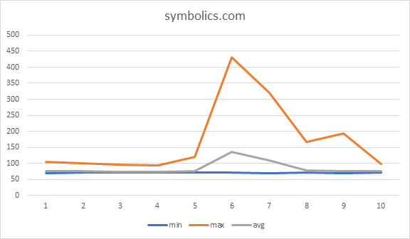  
Fig. 11: symbolics.com ping and packet loss data.

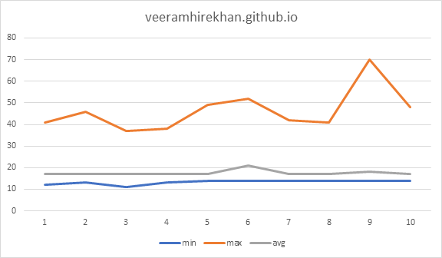

Fig. 12: veeramhirekhan.github.io ping and packet loss data.

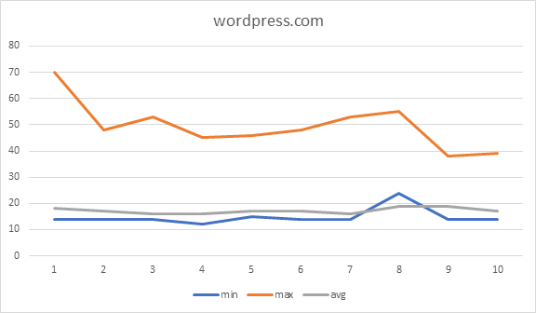

Fig. 13: listedtowumd.wordpress.com ping and packet loss data.

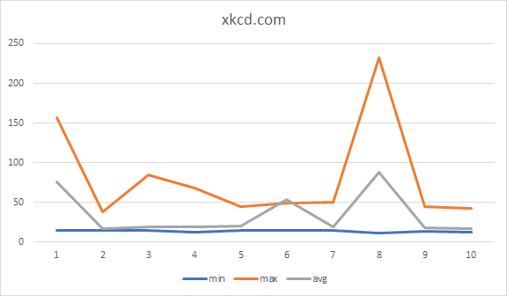

Fig. 14: xkcd.com ping and packet loss data.

***Conclusions***First off, an important factor which may have skewed results is the fact that ping and tracert was used with a wifi connection. A wifi connection is not as reliable as a wired connection which explains the very high and varied maximum ping rates, but not enough to affect the average ping very much. The Troy Library doesn’t see many users until the afternoon/evening, so until then, the router is mostly free which explains not only the lower maximum ping rates, but also the lower minimum and average ping rates across the board as well during the afternoon/evening data retrieval.

A major factor in the variance ping rates and trace routes is most evident in the Troy Librarys network and during weekdays. This shows that once people come to the library, if they connect to the public Wi-Fi as we did, then there was an increasing load on the network. Also, we noticed that on days of events, there was a higher packet loss rate, which was probably due to many people connecting to the network. We can deduce that the Troy Library has a weaker Wi-Fi network, which affected our collection of results, and thus the choke point of the network was also overloaded with requests. As more people come to the Troy Library to work and learn, the more the choke point is loaded with requests.

***What did we learn?***

We learned a few things during the course of this project:

* We have many tools at our disposal and each tool has its own functions and features that go along with it to make it even more powerful.
* These tools are extremely useful to diagnose and possibly optimize our own network if we’re capable and choose to do so.
* There are factors outside your own network that can affect your overall access to the internet. Though many of which are out of your control, there are ways to minimize their effects.

Ping and tracert commands by themselves are useful tools to quickly diagnose simple network problems, but coupled with other features such as ping’s “-n 120” and both ping and tracert > [name of txt file] turn each command into a more powerful form of itself to address more broad problems on a network. The .txt files were extremely useful to easily record information over a long period of time.

Using these tools, we can find and address issues within our own network. Using it, we realized that the Troy Library network is a choke point for incoming and outgoing requests and packets. Though we cannot change anything about that, we can use these tools on our own if we ever have a network to manage ourselves.

Outside factors are outside of our control, but knowing that they’re there, we can make changes to minimize their effect. Knowing the changes internet traffic throughout the day and the average over a course of time can allow us to accurately gauge how much bandwidth and power is needed to handle incoming and outgoing requests therefore reducing the problem.